CONTACT:
Navindren Hodges
(212) 333-2640
info@billhodgesgallery.com
FOR IMMEDIATE RELEASE
Bill Hodges Gallery Celebrates 150 years of African American Artists
Decades of Acquisitions
529 West 20th Street, New York, NY 10011
24 February – 23 April, 2022
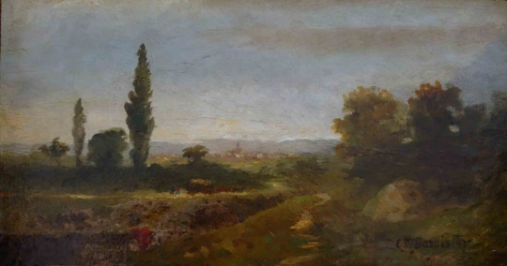
NEW YORK, NY, 11 February, 2022 – Since 1979, the Bill Hodges Gallery has established itself as a collector and exhibitor of works by underrepresented American artists. This upcoming exhibition offers a fascinating glimpse of American art by African American artists.
Decades of Acquisitions: Works on Paper from the Collection presents rarely seen contemporary prints, drawings, and paintings on paper in the collection, ranging from the conceptual to the religious, the landscape, the abstract, and the poetic.
Edward Bannister (1828 – 1901)
The Hay Wagon, Undated
Oil on paper, laid down on panel

The exhibition’s earliest work is by one of its best-known artists. Edward M. Bannister’s The Hay Wagon is thought to have been painted in the early 1880s, as Bannister began to bring impressionistic techniques to bear on his bucolic, Barbizon-inspired landscapes.
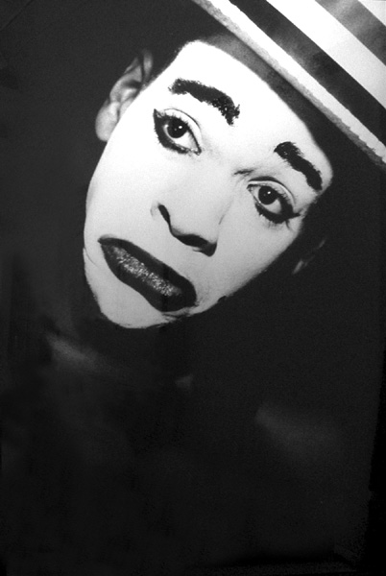
Another significant work featured in this exhibition is Lyle Ashton Harris’s 60 x 40 inch gelatin silver print Minstrel, from 1988. It portrays the artist in whiteface and a straw hat, wearing an exaggerated and perhaps mockingly histrionic frown. An early work, Minstrel heralds Harris’s continued explorations of Black representation in the broader culture, including Harris’s identity as a queer Black man.
Decades of Acquisitions seeks to do more that elevate the works of artists many of whom were denied the public acclaim they deserved and tell the story of American art itself.
Lyle Ashton Harris (1965 - )
Minstrel, 1987-88
Photograph
Historically, American artists have had an uneasy relationship with those from other countries, especially continental Europe. Black American artists have also had a fraught relationship with their domestic peers and audiences. The artists celebrated in this new exhibition saw these tensions, as insultingly dismissive as they sometimes were, as opportunities to develop new visual vernaculars that reflect the American experience more truly—and sometimes painfully—than those of their white counterparts.
Bannister's landscapes are perfect early examples of this. He and William Morris Hunt were the chief American representatives of the Barbizon school. Both became celebrated, award-winning painters during their lifetime in the late 19th Century. But Bannister saw, earlier and more clearly than Hunt, that Impressionism allowed a different and for him a powerfully necessary relationship between the artist and the viewer.
The upcoming exhibition continues this theme by presenting artists using diverse materials and printmaking techniques.
Hale Woodruff’s Torso, a sketch in crayon and charcoal drawn ca. 1960, finds the artist returning to the abstract approach he studied in France, where he married cubist techniques with African themes under the mentorship of expatriate American artist Henry Ossawa Tanner. Woodruff had set abstraction aside after returning from France to document African-American life in the South and traveling to Mexico to study under famed muralist Diego Rivera. Torso announces the last great movement of Woodruff’s artistic life, in which he used cubist techniques explicitly to explore the metaphysical underpinnings of African-American life.
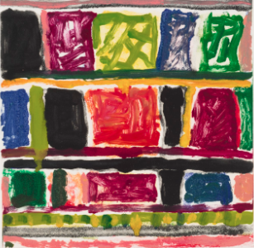
On another note, Stanley Whitney is represented by his signature stacked composition of numerous saturated color fields, Stay Songs from 2002. Proceeding from Whitney’s ongoing experiments with color field painting, this work includes some of Whitney’s most ambitious and electric studies of form to date. It balances the austere and the improvisational, the parlor-room ingenuity of American quilting, and the disciplined flights of bebop jazz, making it, like the entire exhibition itself, a singular statement and a holographic representation of American art.
Stanley Whitney (1946 - )
Stay Songs, 2002
Monotype on paper
Decades of Acquisitions: Works on Paper from the Collection also features works by Wifredo Lam, Norman Lewis, Romare Bearden, Eldzier Cortor, William Carter, Agustin Cardenas, Benny Andrews, Richard Hunt, Charles Gaines, Maceo Mitchell, Henry Ossawa Tanner, Roy DeCarava, Carrie Mae Weems, Lorna Simpson, Willie Cole, William Villalongo, Kara Walker, and Glenn Ligon.
Bill Hodges Gallery is located at 529 W. 20th Street, suite #10E, between 10th Avenue and 11th Avenue. Our closest subway stations are 14th St. & 8th Ave. (A-C-E) and 23rd St. & 8th Ave. (C-E). The gallery is open Monday to Friday from 11 AM – 6 PM. Saturday from 12:30 PM – 5:30 PM. The gallery is implementing social distancing measures and we kindly ask that guests wear appropriate personal protection equipment. Masks and hand sanitizer provided. For more information or to arrange a private viewing, please contact the gallery at (212) 333-2640 or at info@billhodgesgallery.com.

